# Speedcats Car Rental System Training

## Website

The Speedcats Car Rental website can be found at:

**https://still-fortress-58891.herokuapp.com**

This training document describes the desktop version of the Speedcats Car Rental website. Although the mobile version looks slightly different, it functions nearly identically.

**NOTE:** The Speedcats Car Rental website does not function correctly on Internet Explorer, due to some limitations of the browser. Please access the website using Google Chrome, Mozilla Firefox, Microsoft Edge, or Safari.

Home Page

Login or view your profile

Open and close menu

Return to home page

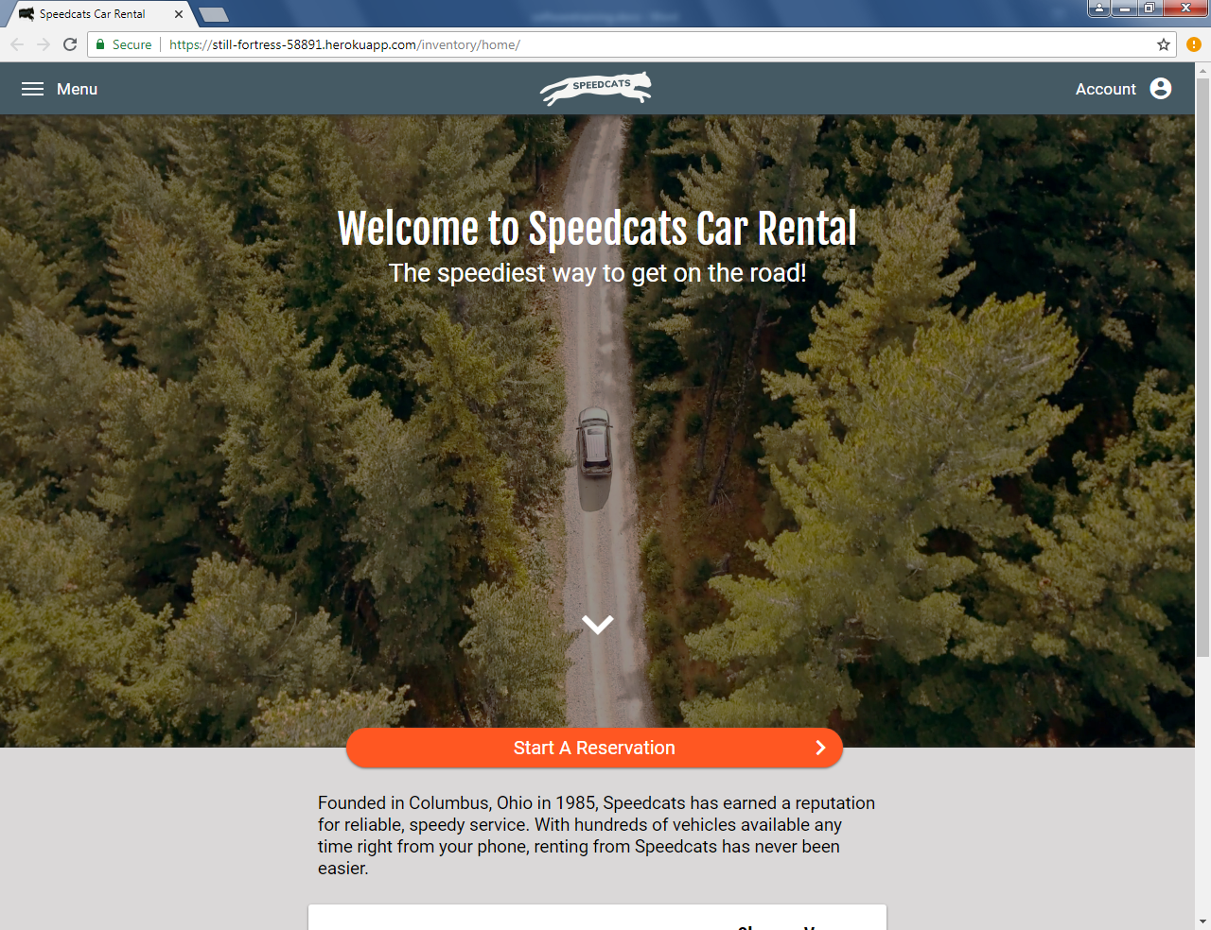

Go to start reservation page

Scroll down to content

Start Reservation Page

Click white rectangles to bring up date and location selectors

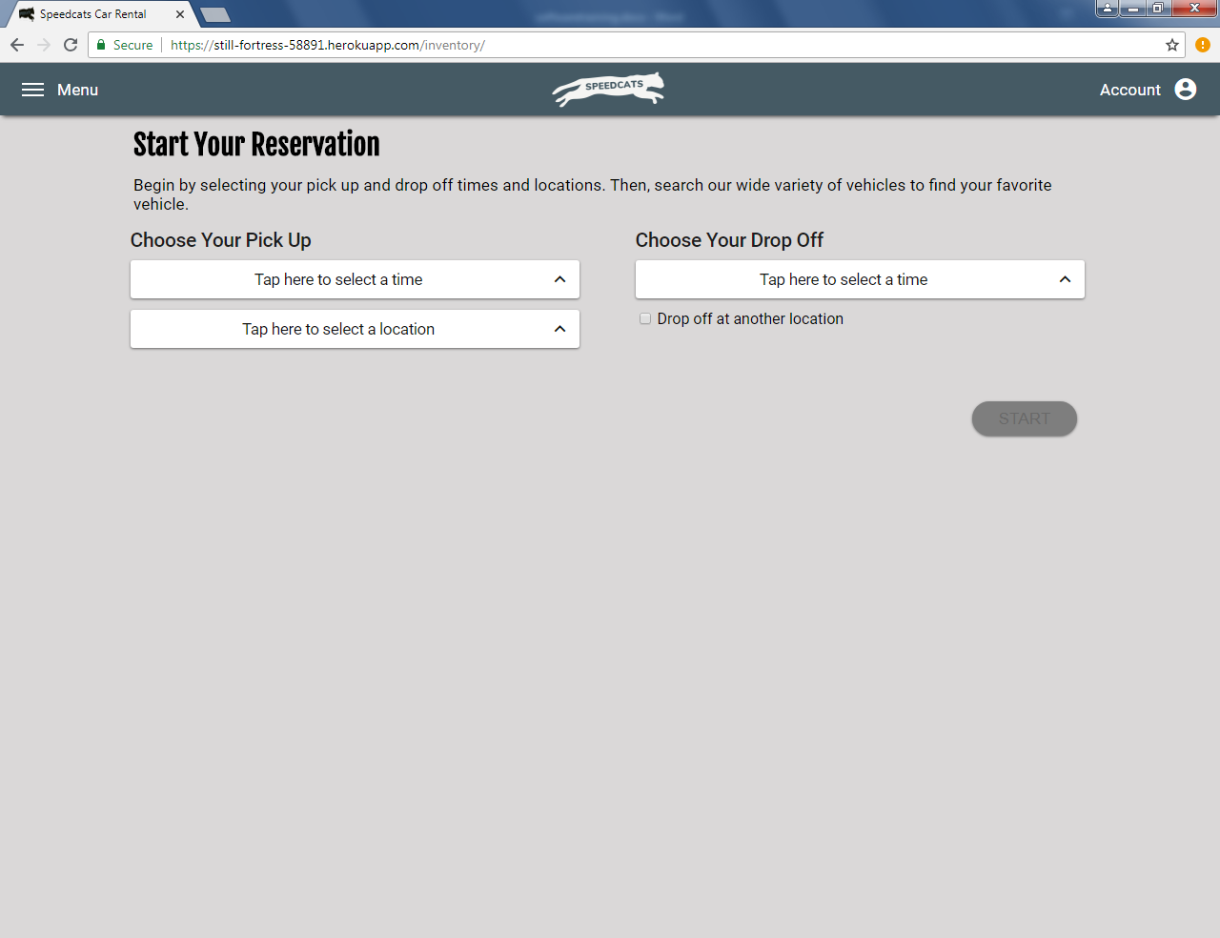

Start button can only be clicked when all information is selected

Check if dropping off location at another store

Click anywhere in the shaded area to close the selector

Use these input boxes to select the date, then the time

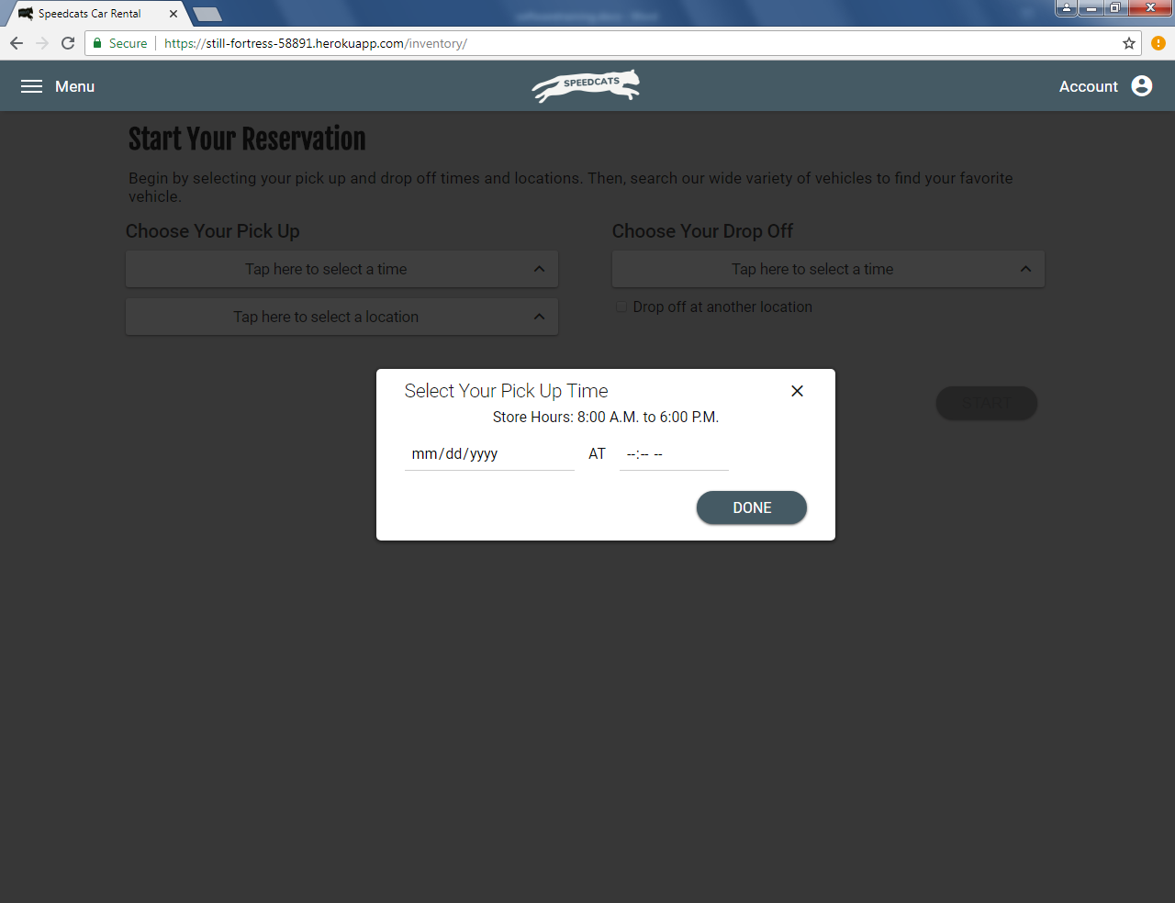

Click done when date and time have been selected

Click anywhere in the shaded area to close the selector

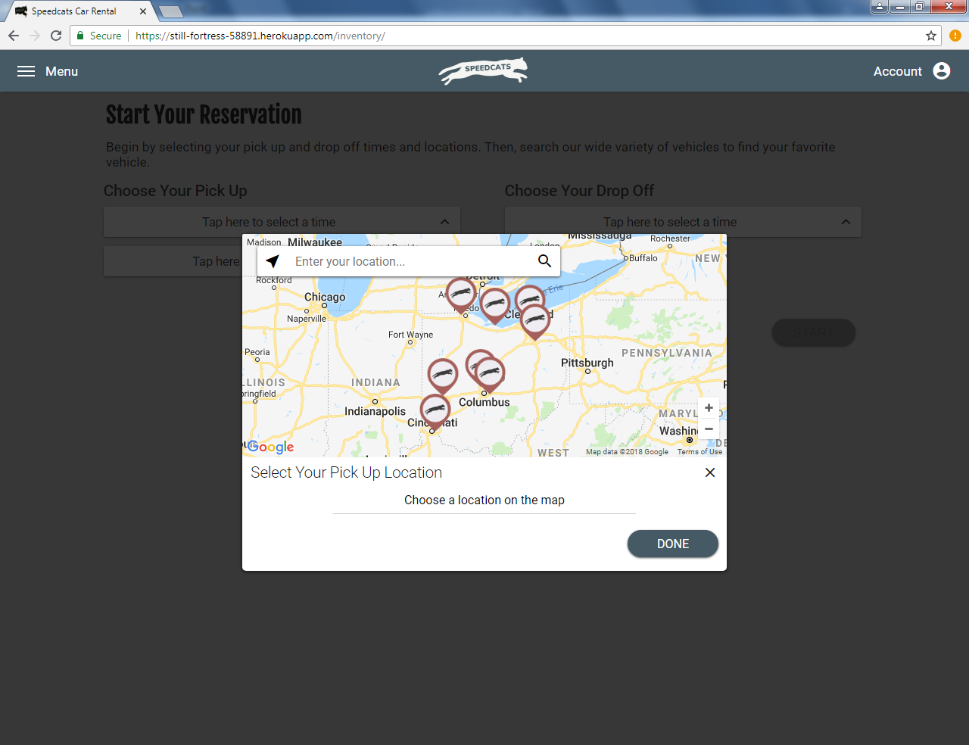

Click done when location has been selected

Click any location to select it. Address will appear below when selected.

Search for a location, then click icon to go

Find current location

After all pick up and drop off information has been selected, click ‘Start’ to view available vehicles

Vehicle List

Current store

Enter search query, then click icon to search

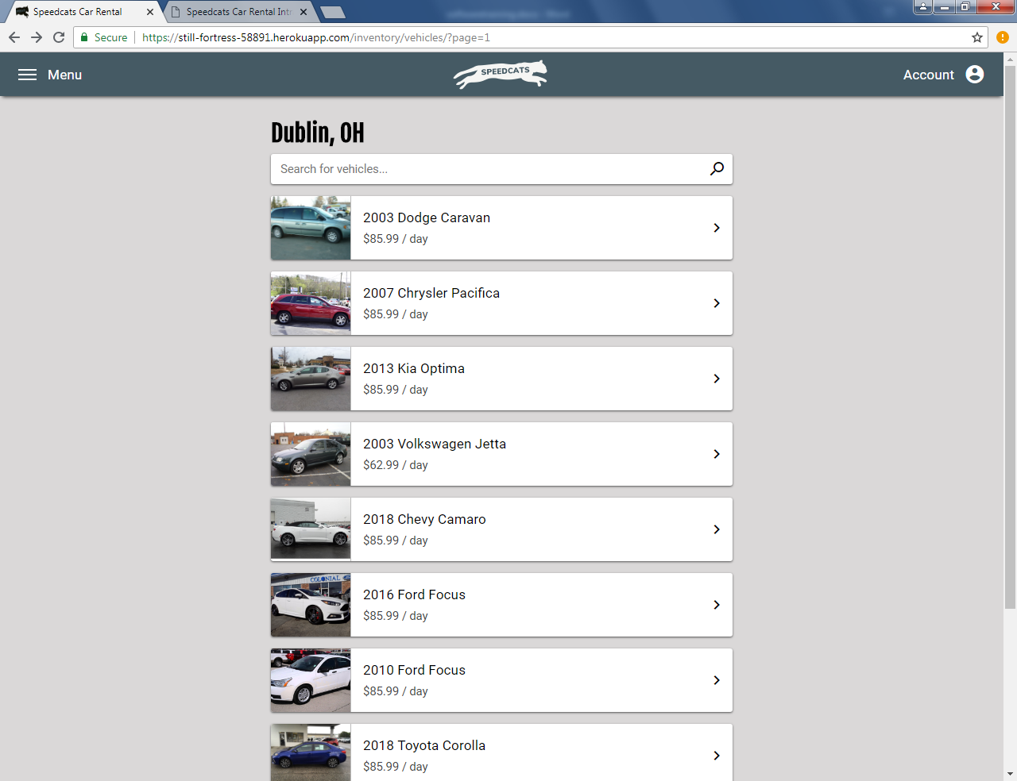

Use arrows at bottom of list to browse pages of vehicles

Click any vehicle to view its details

Vehicle Detail

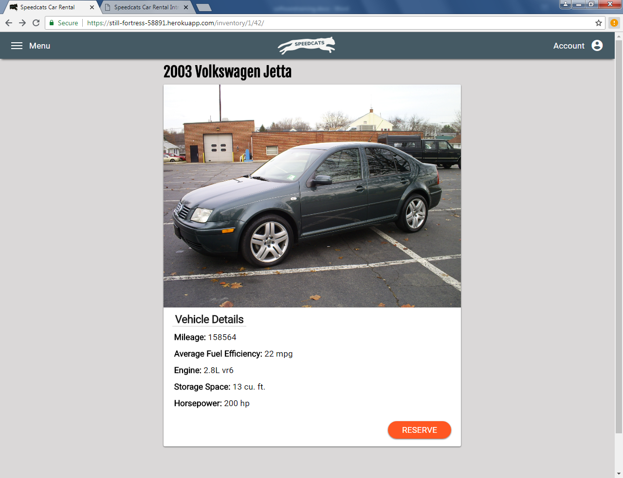

Choose this vehicle for your reservation

Place Reservation

User must be logged in to view this page

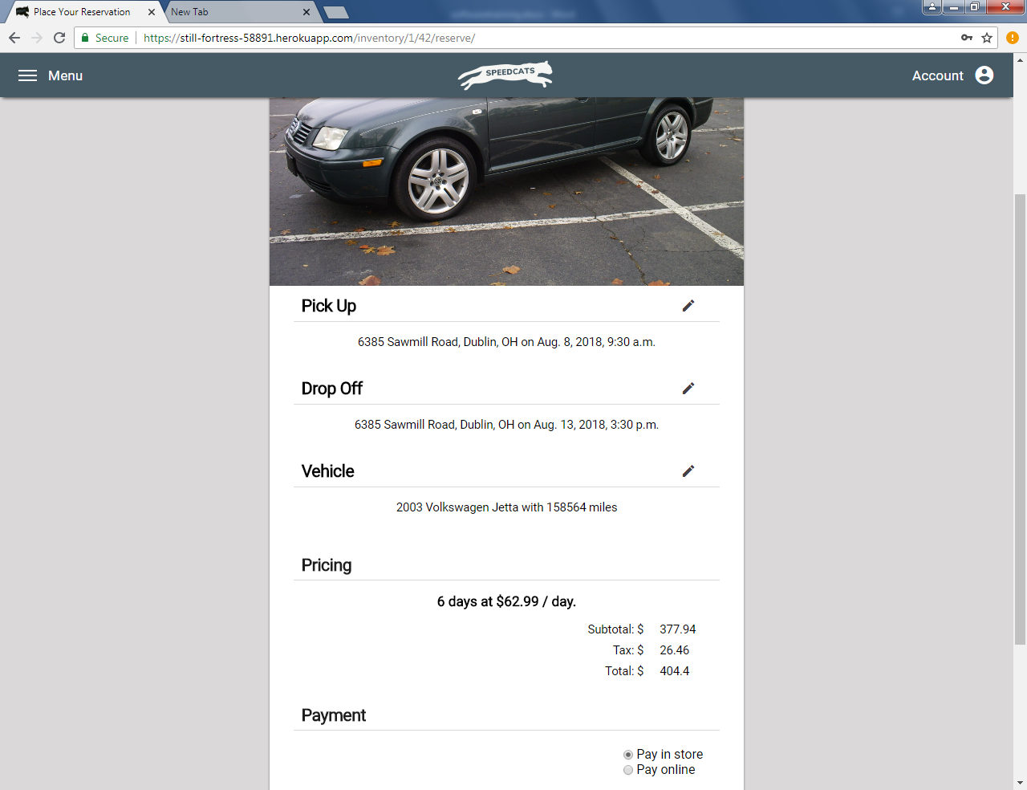

Click buttons at bottom of form to cancel or place your reservation. Cancel returns user to home page. Continue places the reservation and redirects to confirmation page.

Select payment type. If paying online, credit card information must be entered.

Confirm reservation pricing here

Click pencil icons to edit each section

Login

Enter valid username and password, then click “Login” to access your account

Click here to reset password. Enter user’s valid email address to receive an email with a link to reset the password.

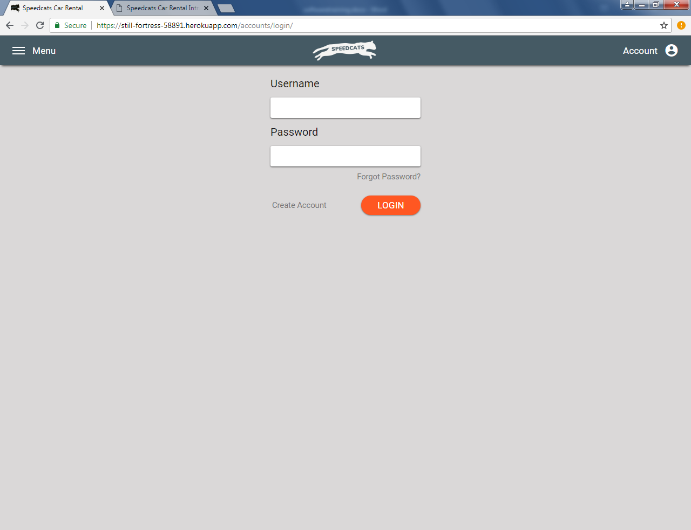

Click to go to account sign up page

Registration

Fill out each item indicated as required, then click register. User will be sent a link via email where their account can be verified.

**NOTE:** User must be at least 18 years old to register and must provide a valid email address

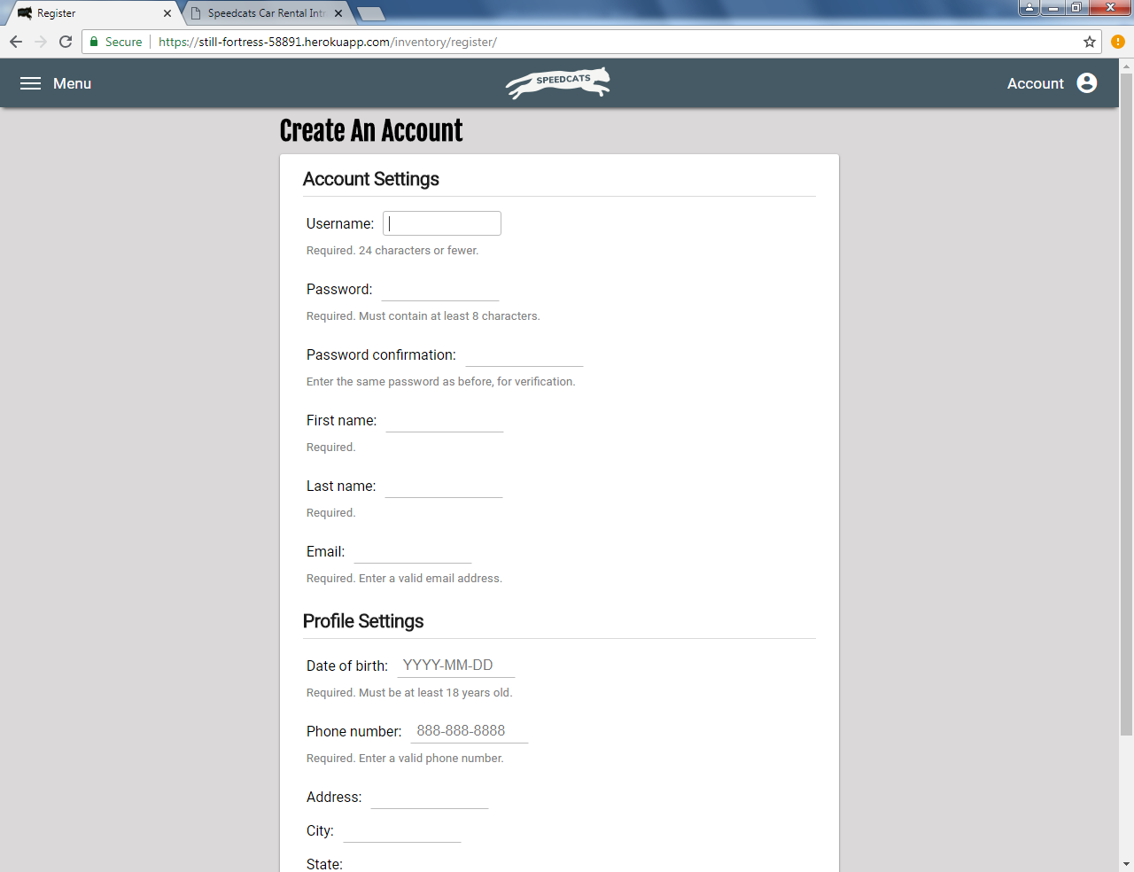

Reset Password

Enter a user’s valid email and click‘Submit’. User will be sent a one-time link via email to reset their password. Upon clicking the link, the user must enter a new password twice for confirmation.

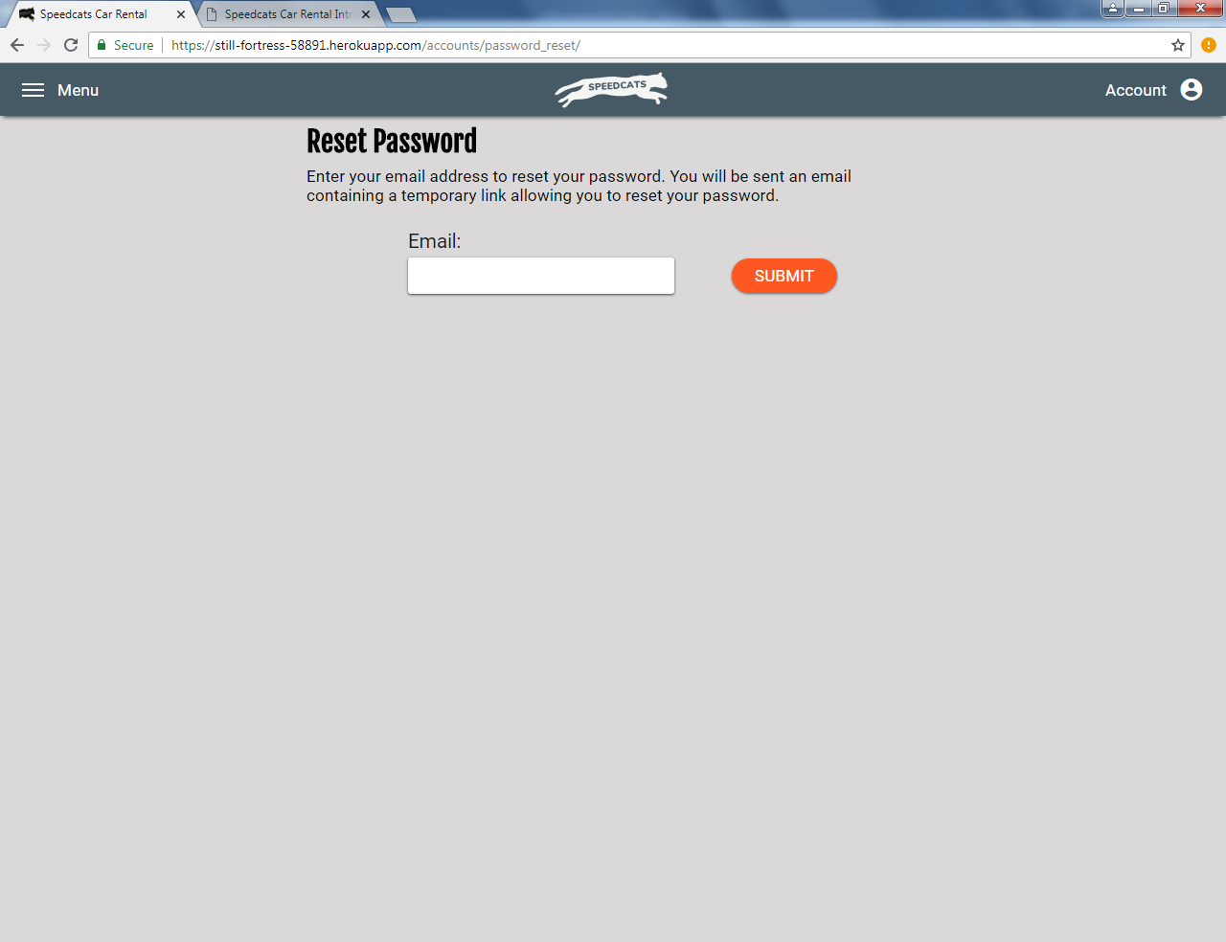

Profile

View user’s upcoming, in progress, and future reservations.

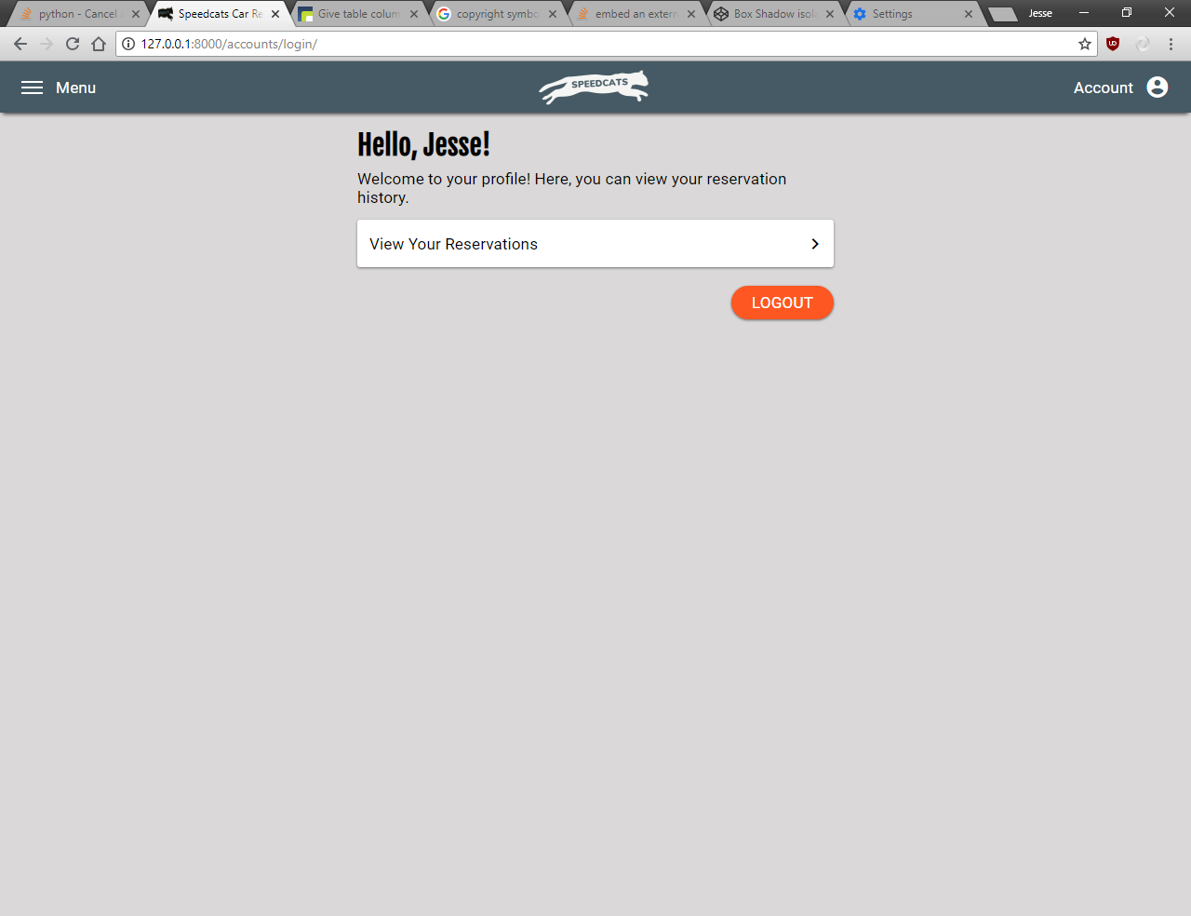

Logout of the account

Reservation History

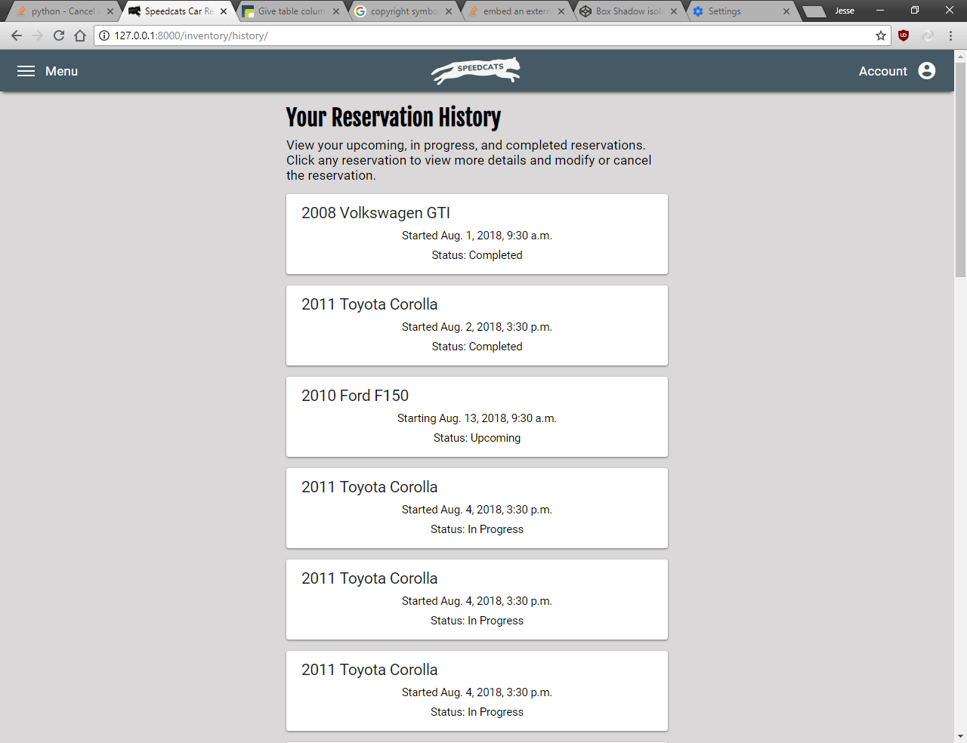

Click any reservation to view details and modify or cancel. Test reservations shown.

Reservation Details

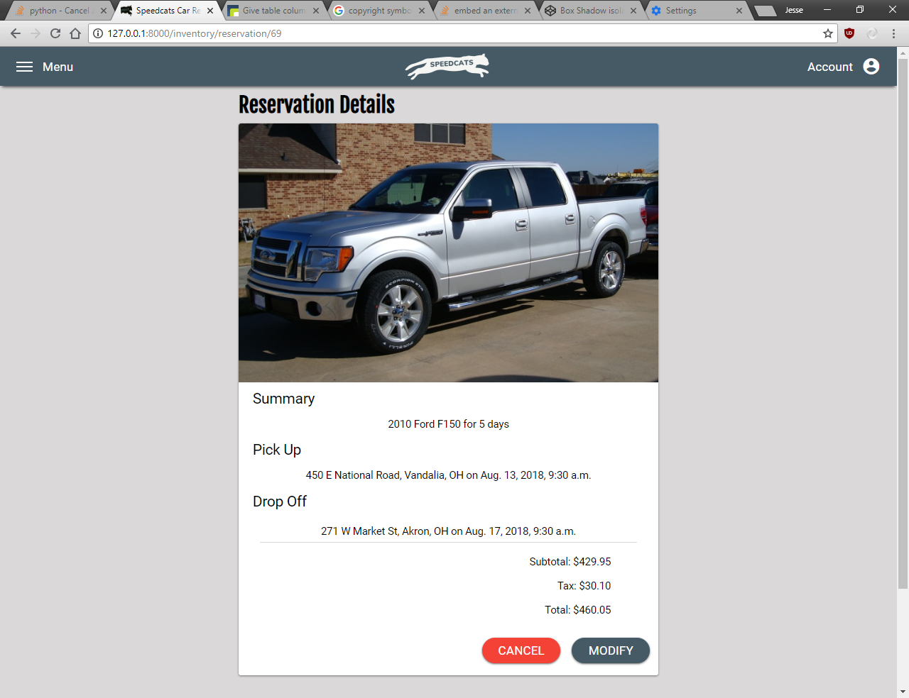

Modify this reservation. User will be redirected to modification page.

Cancel this reservation. A confirmation message will slide up and must be clicked to confirm the cancellation.

View reservation details

Modify Reservation

The number of options available depends on the status of the reservation.

**NOTE:** Vehicles and pickup locations cannot be modified. User must cancel current reservation and start a new one.

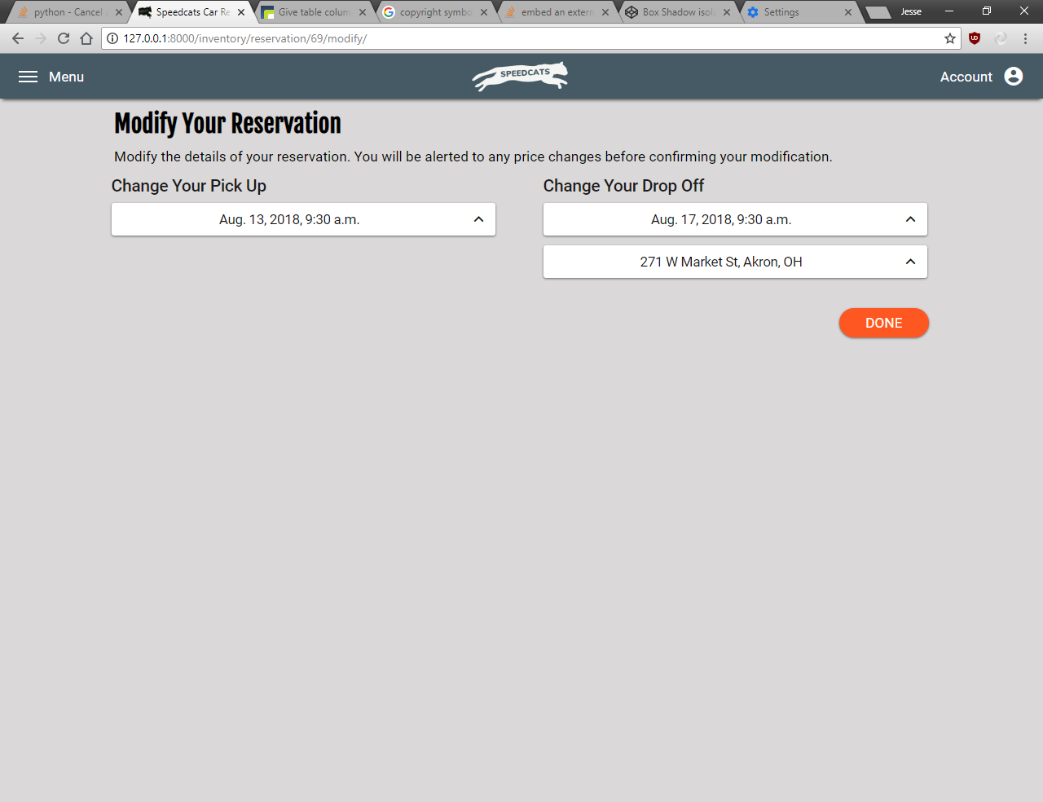

When done is clicked, a confirmation will slide up revealing any changes in prices. User must click confirm on this confirmation to commit the modification.

Refer to pages 3-5 for instructions on how to select date and location settings.

Locations

View a map of store locations and contact information about each store.

**NOTE:** This page currently has limited functionality.

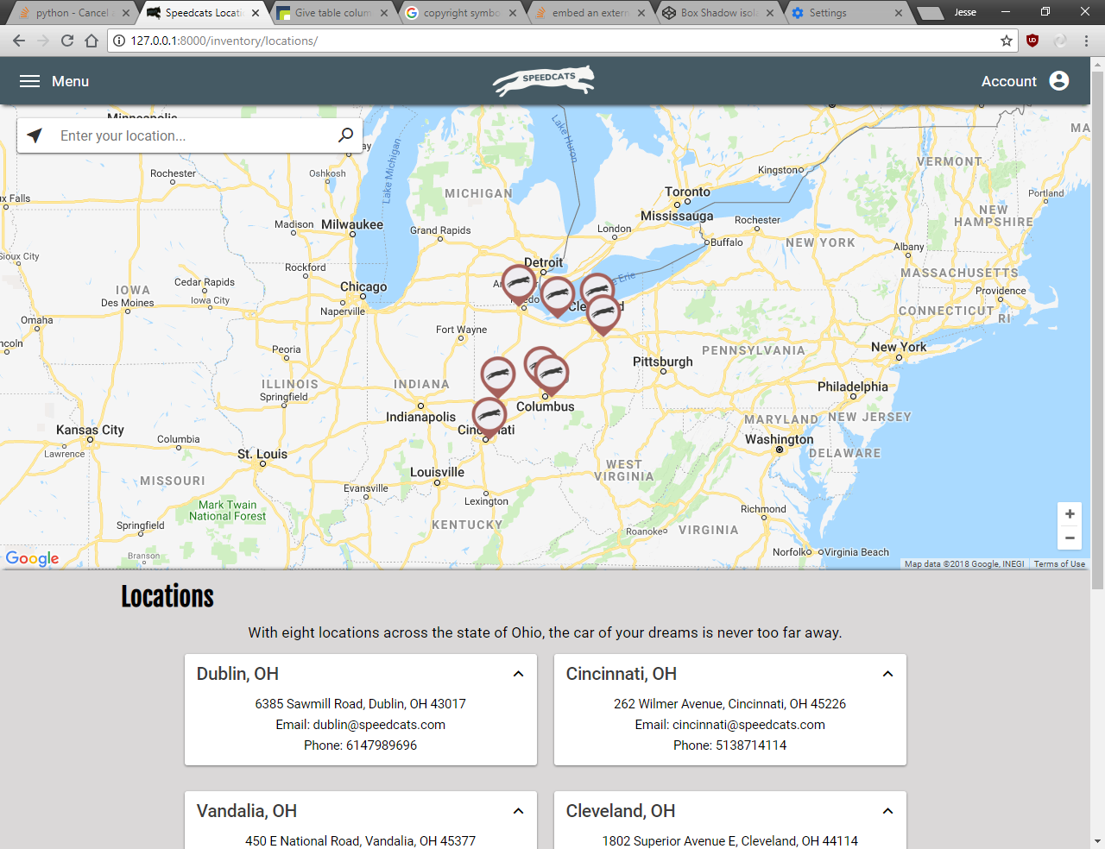

Enter a query and click the search icon to find a location on the map

Find current location

Frequently Asked Questions

Find answers to common questions users may have.

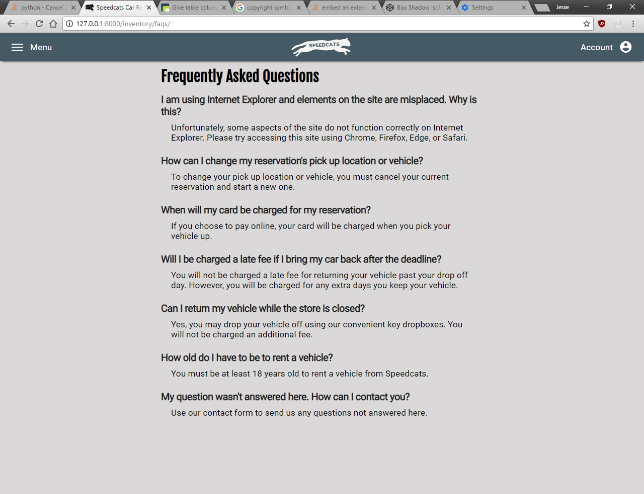

Contact Us

Use this form to contact Speedcats Car Rental for any service questions.

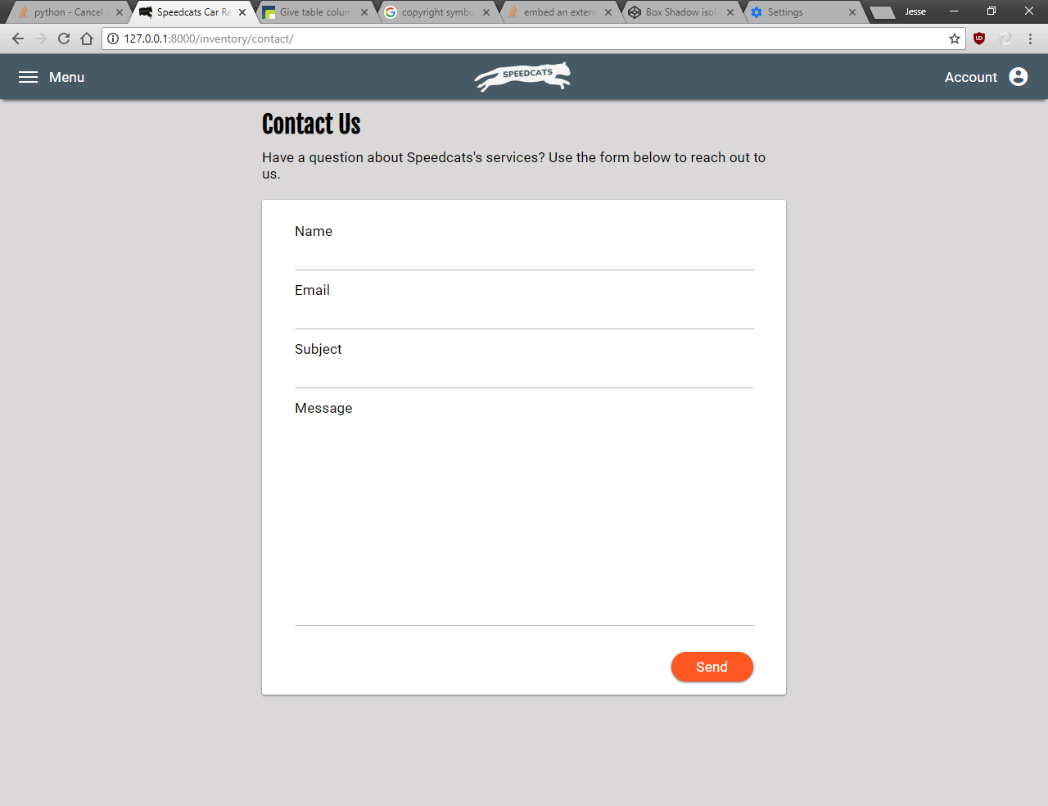

When form is complete, click ‘Send’ to send the message.

User must provide name, valid email, message subject, and message content.

Feedback

Use this form to provide feedback about the Speedcats website or comments about Speedcats’s services. Refer to previous page for instructions on how to fill out this form.

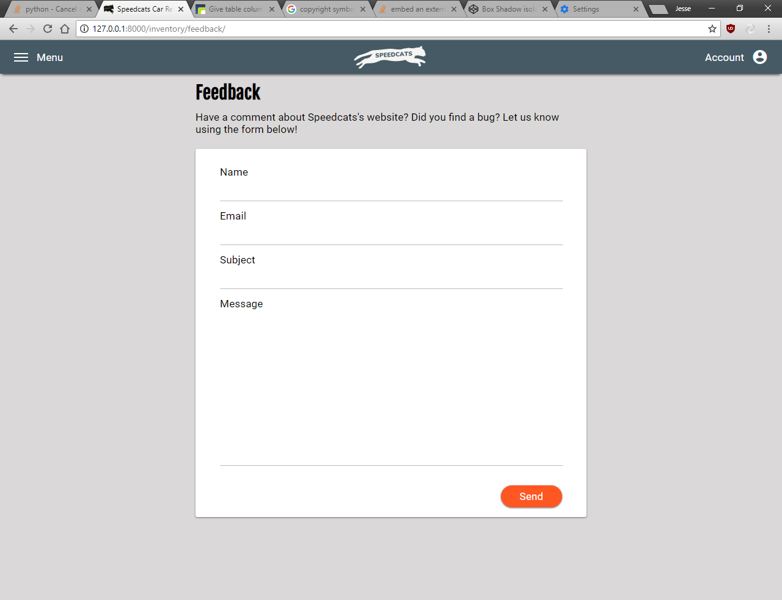

## Intranet

The Speedcats Car Rental intranet site can be found at:

**https://still-fortress-58891.herokuapp.com/admin**

Only accounts with staff status are permitted to access the admin site. If your account requires staff status, please contact an administrator at **ajessefowler@icloud.com**.

This training document describes the desktop version of the Speedcats Car Rental intranet site. Although the mobile version looks slightly different, it functions nearly identically.

**NOTE:** The Speedcats Car Rental intranet site functions correctly on all major browsers.

Home Page

Options may vary based on user group membership and permissions.

View various business and system documentation.

View recent actions made to database

Return home

View user and group settings

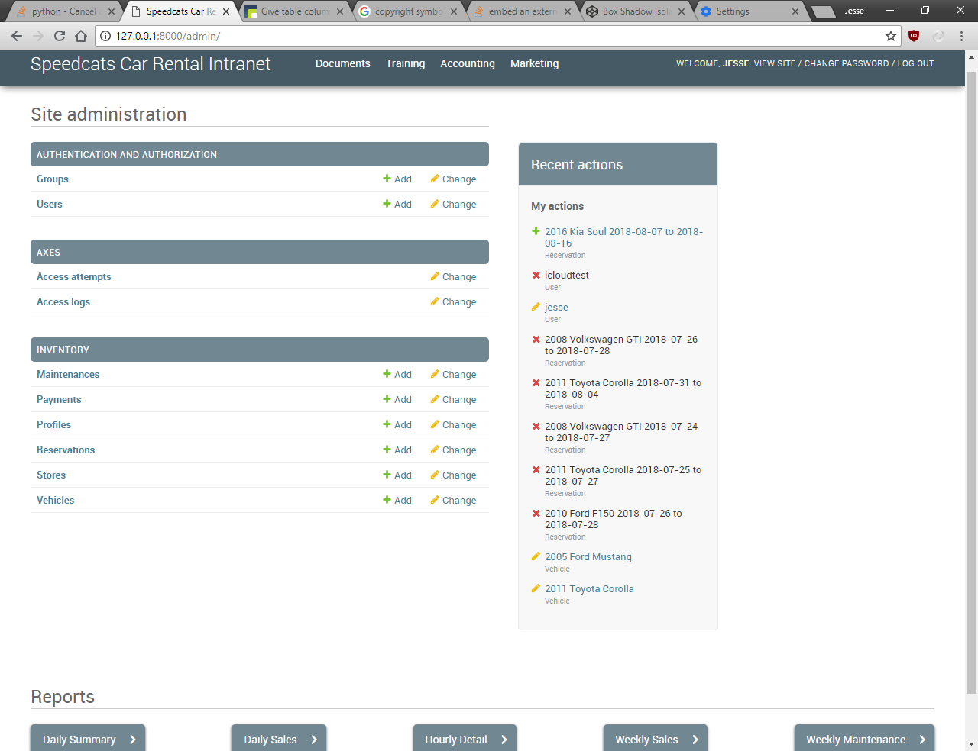

View and modify main system inventory database tables.

View system access attempt logs. Should only be accessed by administrators.

Logout of account

View various business reports, including inventory summaries and details, sales reports, and maintenance reports. When clicked, user will be directed to page with the generated report.

Documentation Pages

All intranet documentation pages function identically.

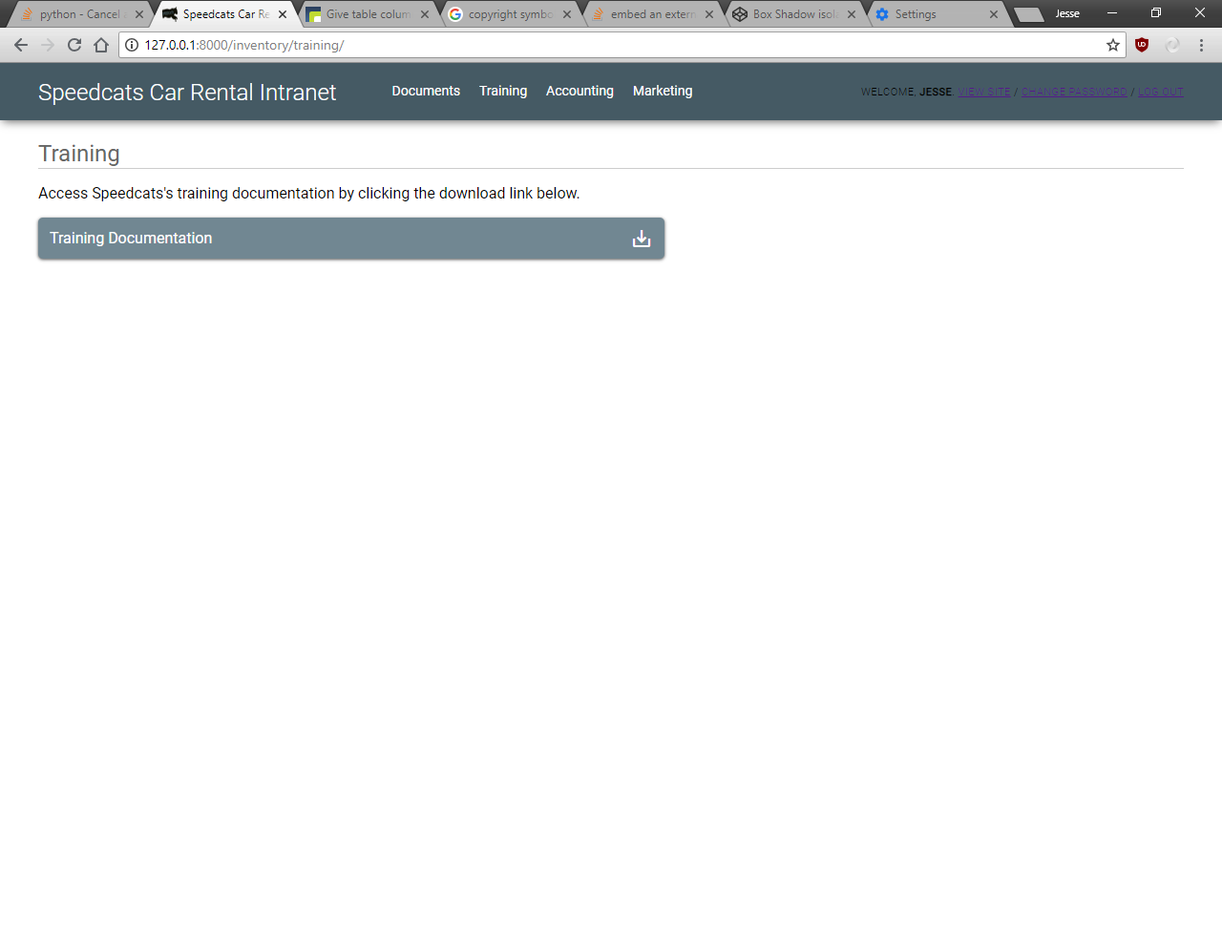

Click this icon to download each documentation file.

Database Tables

View database tables from the inventory system. All database table pages function identically, though options may vary based on the select table and user permissions.

Search records in this database table. Search fields vary.

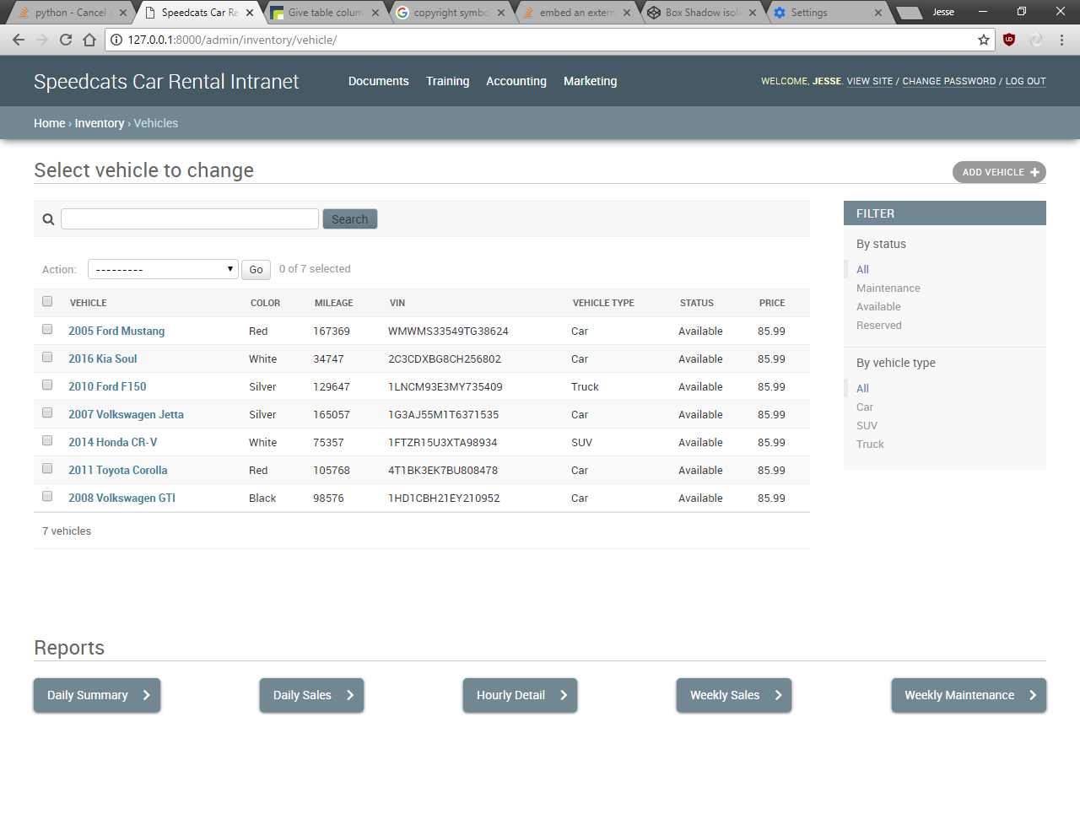

View fields about each record in the table. Click each record’s blue link to view additional details and modify the record.

Filter table by various fields.

Add new record to this table.